Postal Life Insurance
Department of Post

Software Requirements Specification (SRS)

Policy surrender

- Executive Summary

This document outlines the business requirements for Policy Surrender with Illustrations of Insurance Management System (IMS). It aims to processing of Surrendering of a Policy as per the ruling provided .

- Business Objectives

The IMS project addresses the requirement of surrendering of a Policy by the Insurant and when required . This system will index the surrender request, process and effect the payments .

- Project Scope

Policy surrender will be a module of the Insurance Admin system used by Insurant/Customer as and when required and unwilling to continue the policy .

4. Business Requirements

- Functional Requirements Specification
Surrender value of a policy, is the amount that is payable to the Insurant, when he/she foregoes the contingent benefit of his policy and surrenders it for an immediate payment. Surrender value depends on the surrender factor and type and term of policy and as per the prescribed ruling mentioned in POLI
Business Logic
- Policy should be in force
- Policy should have been completed 36 months.
- If there is any defaults of Premium (for less than 3 years policy, 6 months and for more than 3 years 12 months grace period), premium should be deducted with Interest amount from surrender value along with any other deductions as applicable
- For policy attained Maturity , should be treated for Maturity process only
- For WLA policies(PLI & RPLI) beyond maturity period eligible for Surrender
- AEA & GY policy is not eligible for Surrender
- If the defaults are other monthly mode like Quarterly, Half annually & Annually premium is to calculated for Monthly and proportionate amount is to be deducted along with Interest and other deductions as applicable.
- Necessary documents written consent , policy bond, premium receipt book,Pay recovery certificate . Loan receipt book,loan bond etc , indeminity bond for the lost policy are to be displayed in the system and obtained from customer while processing.
Calculation Logic
Cumulative age: Date of application for surrender-Date of birth(15days or more will be counted as 1 month)
Paid_up_value:(Number of Premiums Paid*sum assured amount)/Total number of Premiums Payable
Surrender value: Paid-up Value + Bonus)* Surrender Factor(Ref:Surrender factor table)-Unpaid Premium-Unpaid Loan Principle and Interest
Surrender Paid in Advance
For policies in respect of which premium is paid annually in advance, surrender value is to be calculated at the end of the year irrespective of the date of surrender but payment of surrender value may be made when the policy holder asks for it.
Surrender Date calculation in monthly mode:
Policy shall continue to be in force till the end of the month in which the application for surrender is received.Accordingly the premium shall also be payable for the period for which the policy continues to be in force.
Surrender Date calculation in Annual mode:-
Surrender value is to be calculated at the end of the year irrespective of the date of surrender but payment of surrender value may be made when the policy holder asks for it.
Bonus: Nil for less than 5 years
For more than 5 years : - proportionate to the reduced SA
Bonus calculation on paid-up amount :- (Bonus rate*Paid Up value)/1000 .
Payment: Paid to Insurant or Assignee for assigned policy
Product Type | Product Name | Surrender Allowed (Y/N)
Whole Life Assurance | Suraksha- Whole Life Assurance | Yes, after premium payment of 4 yrs.
Endowment Assurance | Santosh-Endowment Assurance | Yes, after premium payment of 3 yrs.
Convertible Whole Life Assurance | Suvidha - Convertible Whole Life Assurance | Yes, after premium payment of 4 yrs.
Anticipated Endowment Assurance | Sumangal - Anticipated Endowment Assurance | No
Endowment | Child Policy | Yes, after premium payment of 5 yrs.
Endowment Assurance | Yugal Suraksha - Joint Life Assurance | Yes, after premium payment of 3 yrs.
RPLI:
Product Type | Product Name | Surrenders Allowed (Y/N)
Whole Life Assurance | Gram Suraksha- Whole Life Assurance | Yes, after premium payment of 4 yrs.
Endowment Assurance | Gram Santosh-Endowment Assurance | Yes, after premium payment of 3 yrs.
Convertible Whole Life Assurance | Gram Suvidha - Convertible Whole Life Assurance | Yes, after premium payment of 4 yrs
Anticipated Endowment Assurance | Gram Sumangal - Anticipated Endowment Assurance | no Surrender
Endowment | Child Policy | Yes, after premium payment of 5 yrs.
10 year Anticipated Endowment Assurance | Gram Priya | No Surrender
Quote screen:
Quote Type: Surrender
Policy Number:
Current date

Display Screen:
Policy Number:

Name:
Policy status:

Customer Id:

Product Name:

Policy issue date:

Paid till date:

Duplicate Policy bond:

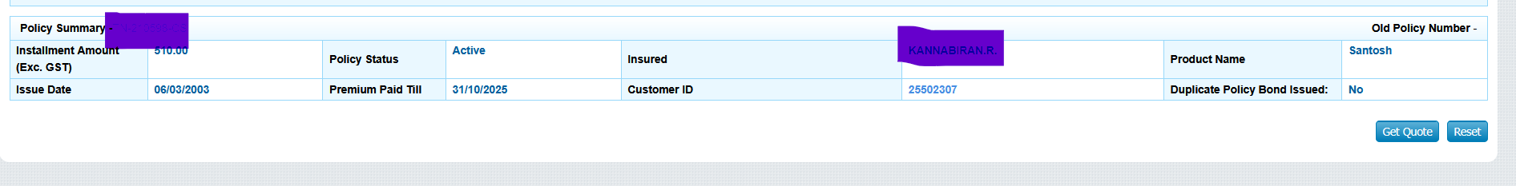

After clicking Get quote:

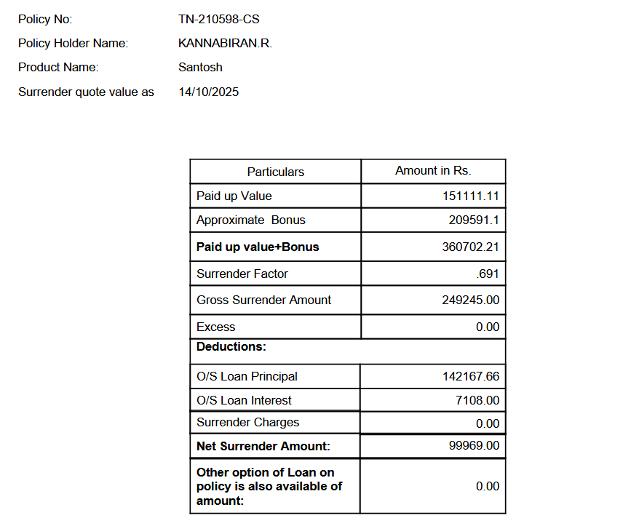

Bonus details:
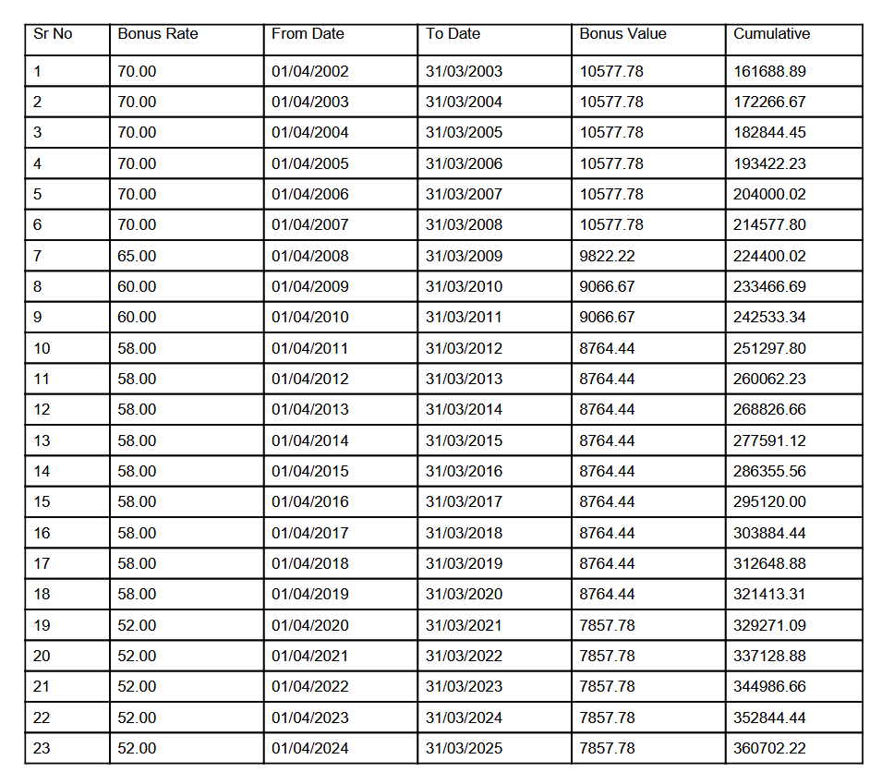

Surrender claim Indexing
Policy Number :

Service request Type(drop Menu): Surrender Claim

Display : As in Quote mentioned above
After submitting: Generating Service Request Number after checking all the conditions and rulings on the policy
Surrender Process At CPC

Calculation of Surrender Value(example)

Plan Type:EA
Entry Date:01-Jan-2007
Age at Entry:33
Age at Maturity: 60
Date of Birth:10-Jan-1974
SA:20000
Bonus: 10000
Premium paid upto :31-Dec-2025
Date of Application:31-Dec-2025
Premium:100
Paid Up Value:20000x(18x12)/((60-33)x12)=20000x216/324=13333
Surrender Factor Value:0.725(not exact value)
Surrender Value: (13333+10000)*0.725
Net Value: 16916

